BRITISH SWIMMING DIVERSITY, EQUITY AND INCLUSION (DEI) REPORT 2023

Introduction

British Swimming sits in a unique position within the sport’s governing body system, given our focus on elite performance on the world stage. The expectation for us to be leading in this area has never been greater. Responses to a 2023 survey demonstrated themes amongst respondents when it comes to what British Swimming should be known for now and in the future. This includes having a positive influence, leadership, setting the standard and raising awareness. We continue our journey from our annual DEI Survey to report on the work and development in this key area.

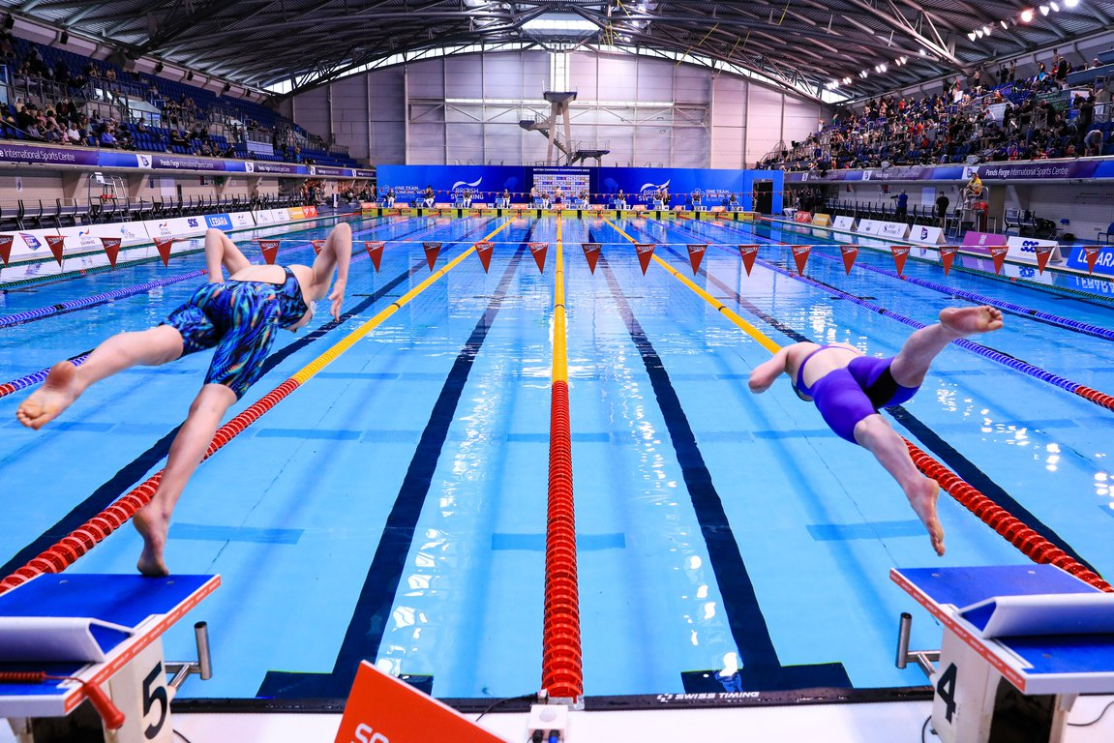Alt text: picture of two swimmers in lane 4 and 5 diving into a pool
Why we’re doing it?
“Attracting the best talent to the organisation, regardless of their background, is an essential part of our success.”
Focussed approach to Equity
Firstly, we strengthened our commitment for the organisation to focus on Equity rather than Equality. Equality means each individual or group of people is given the same resources or opportunities. Equity recognises that each person has different circumstances and allocates the resources and opportunities needed to reach an equal outcome. Our upcoming Diversity Equity Inclusion Action Plan will outline the current inequalities and how we can develop this space for the future. All our future communications will reference DEI, replacing EDI.
Why commit to DEI?
Attracting the best talent to the organisation, regardless of their background, is an essential part of our success. Allowing employees and athletes to feel supported within their environment is key to satisfaction within an organisation. Furthermore, perhaps the most important outcome of a positive employee and athlete experience is high performance, both in terms of employee achievement and the organisation’s long-term outcomes. An inclusive workplace culture ensures that the contributions, talents, skills, and perspectives of all employees are welcomed and utilised in ways that help the organisation achieve our vision.

To stay motivated and consistently perform well, employees and athletes need a work environment that offers them a positive employee experience and where every team member feels empowered and supported. It’s also vital commercially to diversifying the organisation alongside attracting and retaining high performing, happy employees who continue to support elite success. Our recent employee and athlete surveys gave us a key benchmark and comparison on previous years.
The Diversity Equity Inclusion Action Plan (DEIAP)
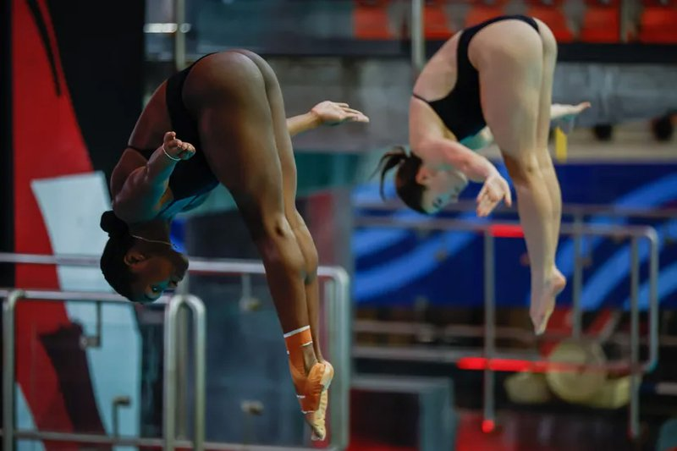
The DEIAP outlines British Swimming’s ambitions for progressing DEI across all levels of the organisation. The 2024-2028 DEIAP will build upon the existing work conducted for the previous plan and forms part of the revised Code for Sports Governance, which requires organisations in receipt of UK Sport and/or Sport England funding to publish ‘clear ambitions to ensure that their leadership represents and reflects the diversity of the local and/or national community’.
Alt text: Picture of two synchronised divers

What we have done

We have provided greater feedback opportunities
For the first time, we opened the communication channels to give us a more in-depth opportunity to hear the views from across our organisation. Equipped with both demographic and qualitative data, we worked alongside partners, within and outside of British Swimming, to refine and strengthen the direction of travel.

We have recognised international success, while aiming to be more representative of society
The past year continued to bring both sporting and global challenges, but we have continued to demonstrate the power of sport and this is reflected in our successes both at the national and international level. Our athletes are recognised globally as being some of the best in the world, whilst our employees continue to represent the organisation on the international stage at conferences, congresses and wider high-performance events. Increased success brought more media interest and athletes across the disciplines have been more open in talking about their experiences. Skye Carter, Robbie Lee and Desharne Bent-Ashmeil have been open about their own personal journeys.

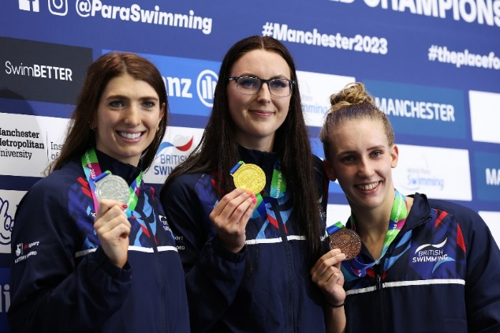
We have recruited a DEI Advisory Group
We’ve recruited 8 members to our new Inclusion Advisory Group, which will bring together a collective and representative demographic of internal and external champions to support, advise and monitor how the organisation can promote an inclusive culture, champion diversity and anti-discrimination across the aquatic sports. With a range of lived and professional experiences, diversity of thought and internal perspectives to enhance the way we operate, the group will come together for the first time in early 2024 and engage with us to develop how we continue to become more inclusive, with performance at the heart of the decisions we make.
Alt text: Jessica-Jane Applegate, Bethany Firth and Louise Fiddes smiling with medals at Manchester Para-swimming World Championship

We have become Diversity Confident employers
As a member of the Disability Confident Scheme, British Swimming has guaranteed job interviews to applicants with a disability who meet the essential criteria for a number of years now. To help address the underrepresentation of ethnically diverse employees in the workforce we have similarly committed to guaranteeing a job interview to any applicant from an ethnically diverse background who meets the essential criteria for a role.

Our Organisations Representation Data (Employees and Athletes)
“In 2023, British Swimming achieved our most ethnically diverse and representative survey yet.”

In 2023, British Swimming achieved our most ethnically diverse and representative survey yet. Getting up to speed with representing the general population however requires us to be more targeted in our actions and to listen to the data. This will determine the initiatives we deliver and the potential for growth, alongside recognising where we need to develop.

Our rates of representation have increased in those identifying as non-white (9.95%), LGB (6.80%) and those with a disability (22.82%) across the organisation. We also continue to represent gender diversity across the organisation with an almost equal split.

This progress, however, is tempered by the knowledge that these figures are not reflective of society from the latest Census data in 2021 and we must continue to improve the representation of ethnically diverse and those with a disability across all categories. We also see feedback themes relating to providing a more diverse Board and women at senior coaching/leadership level. These particular themes will inform our priorities moving into 2024.
Employee and Athlete Representation Data
In 2023, 206 total demographic responses (71 Employees and 135 Athletes)

 | Census Data (2021) of General Population | British Swimming Survey Results 2022 | British Swimming Survey Results 2023
Identify as White (All White Categories) | 81.7% | 92.92% | 87.86%
Identify as Non-White (All Non-White Categories) | 18.3% | 6.3% | 9.95%
Identify as LGB+ | 3.2% | 4.9% | 6.80%
Did not answer question/Prefer not to say (LGB+) | 7.5% | 5.59% | 9.22%
Identify as disabled (employees, board and athletes) | 17.7% | 16.08% | 22.82%
Employees identified as disabled (Board and employees) | - | 6.94% | 5.63%
Religion
- Christian | 46.2% | 39.16% | 37.04%
- No religion | 37.2% | 56.64% | 57.04%
- Muslim | 6.5% | 0% | 0%
- Hindu | 1.7% | 0% | 0%

Which of the following categories best describes you?
 | 2021 | 2022 | 2023
Employee/Board/Committee Member | 35.14% | 41.96% | 34.47%
Athlete – Olympic Swimming | 16.22% | 23.78% | 28.16%
Athlete – Diving | 11.49% | 6.99% | 14.56%
Athlete – Paralympic Swimming** | N/A | 18.88% | 21.84%
Athlete – Artistic Swimming | 8.78% | 0.00% | 0.97%
**Swimming demographic data was merged for OLY and PLY pre-2022.

Race/Ethnicity
 | 2022 | 2023
White – English/Welsh/Scottish/Northern Irish/British | 92.92% | 87.86%
Mixed or multiple ethnic groups including white and black Caribbean, white and black African, white and Asian | 4.2% | 6.8%
Asian or Asian British including Indian, Pakistani, Bangladeshi, Chinese | 0.7% | 0.97%
Black, African, Caribbean or Black British | 0.7% | 0.49%
Any Other | 0.7% | 1.46%
Prefer not to say | 0.7% | 2.43%

Gender
 | 2022 | 2023
Female | 48.25% | 49.51%
Male | 51.75% | 50.00%
Prefer not to say | 0% | 0.49%

Gender at Leadership Level (Board and Senior Management Team)
 | 2023
Female | 50.00% (10)
Male | 50.00% (10)

LGBTQ+
 | 2021 | 2022 | 2023
Bisexual | 2.03% | 0.70% | 1.94%
Gay/Lesbian | 0.00% | 2.10% | 4.85%
Heterosexual/ Straight | 93.24% | 89.51% | 83.98%
Prefer not to say/ Did not answer | 1.35% | 5.59% | 9.22%
Other (please specify) | 1.35% | 0.00% | 0.00%

Disability
 | 2022 | 2023
Yes, I have a disability (Overall) | 16.08% | 22.82%
No, I do not have a disability | 83.92% | 77.18%
Yes, I have a disability (Employees) | 6.94% | 5.63%

What our people are saying

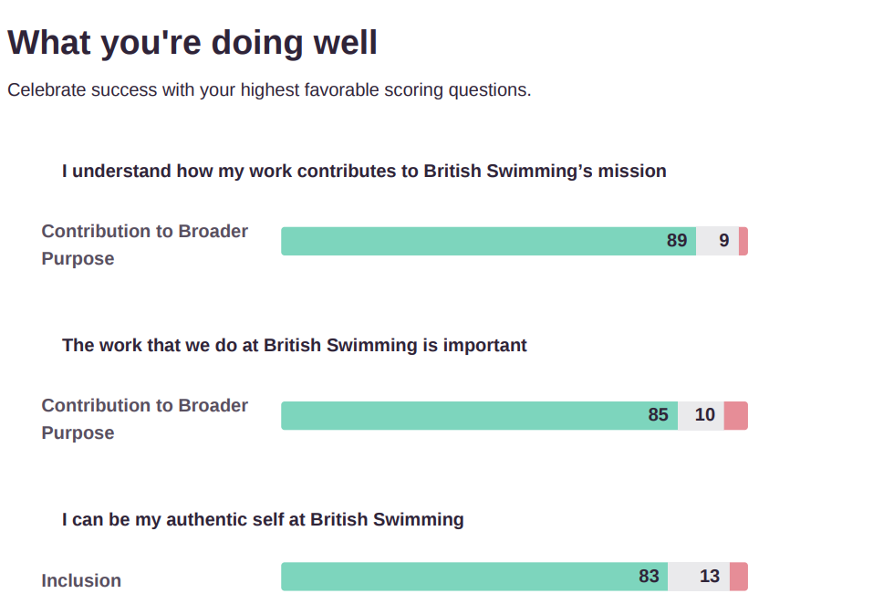
This year we partnered with an external employee engagement company, Culture Amp, who delivered our most engaging and qualitative DEI Survey. It allowed employees, athletes and the Board to feedback their thoughts and scores and provide us with invaluable information relating to the organisation. Below are a roundup of the areas with the strongest levels of feedback.
Alt text: Headline: what you're doing well, celebrate success with your highest favorable scoring questions. Three top scores were “I understand how my work contributes to British Swimming’s mission”, “The work that we do at British Swimming is important” and “I can be my authentic self at British Swimming”.

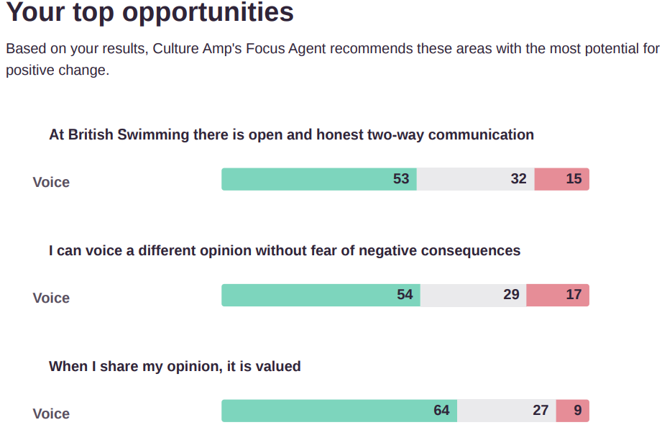

When the data is split into responses from athletes and employees, the data demonstrates a similar picture for the top three opportunities.
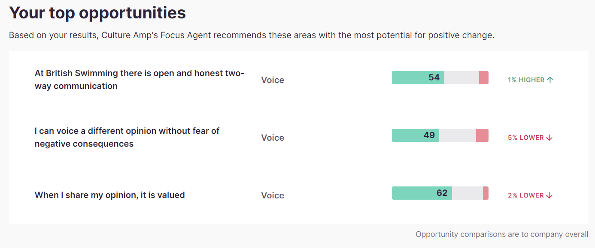
Alt text: heading your top opportunities. Top three questions are “At British Swimming there is open and honest two-way communication”, “I can voice a different opinion without fear of negative consequences” and “When I share my opinion, it is valued”

What are we doing moving forward?

Comments are being collated and themes developed into an action plan for British Swimming’s Senior Management Team to review. It is clear from the above that opportunities for employees and athletes to communicate and voice opinion is an area the organisation can improve. This action plan will be transparent and regularly communicated to all employees and athletes once agreed by the Senior Management Team. Our Diversity Inclusion Action Plan is also due for release in 2024 outlining how we develop the sport to be more inclusive both from an athlete and wider organisation perspective.

