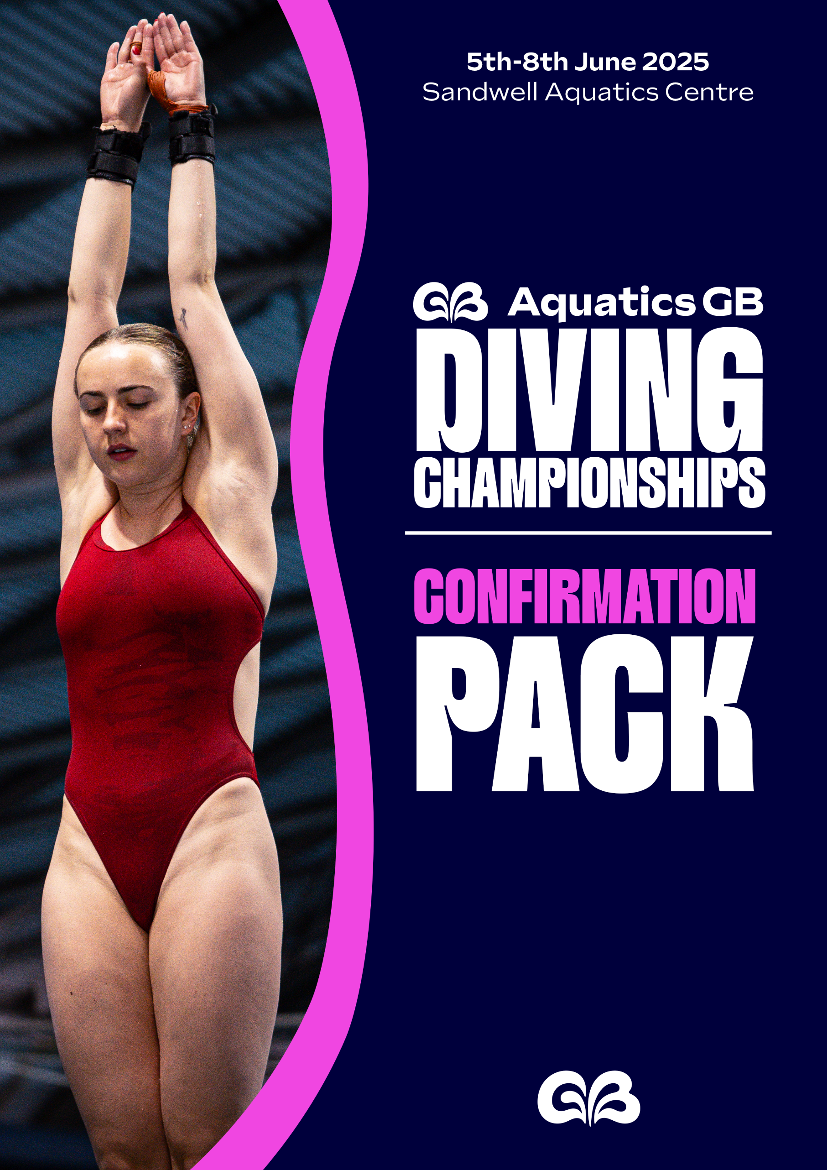
CONTENTS

CONTACT INFORMATION 3
KEY DATES AT A GLANCE 4
TRAINING 4
COMPETITION 4
TICKETS 4
MERCHANDISE 5
SCHEDULE OF EVENTS 5
TECHNICAL MEETING 6
DIVE SHEETS 6
EVENT CONDITIONS 7
INDIVIDUAL (TABLE 1.1) 8
SYNCHRO (TABLE 1.2) 9
PERFORMANCE STANDARDS FOR NATIONAL CHAMPIONSHIPS (TABLE 1.3) 9
DOPING CONTROL 9
ACCREDITATION 10
ATHLETES 10
COACHES, TEAM STAF, CHAPERONES 11
DBS/ PVG AND SAFEGUARDING 11
MINIMUM QUALIFICATIONS/REQUIREMENTS (SPECIFIC TO ACCTREDITED ROLES) 12
MEDICAL 12
SEXUAL HARRASSMENT POSTER 13
FILMING AND PHOTOGRAPHY 14
FILMING AND PHOTOGRAPHY POLICY 14
EVENT PHOTOGRAPHY AND FILMING 14
PHOTOGRAPHY REFUSAL FORM 16
ENTRIES 17

CONTACT INFORMATION

Aquatics GB Contact | Venue Contact
Holly Martindale  Aquatics GB  SportPark  3 Oakwood Drive  Loughborough  LE11 3QF  holly.martindale@aquatics.gb.com  +44 (0) 7583 029 285 | Sandwell Aquatics Centre  Londonderry Ln  Smethwick  B67 7EW  Website

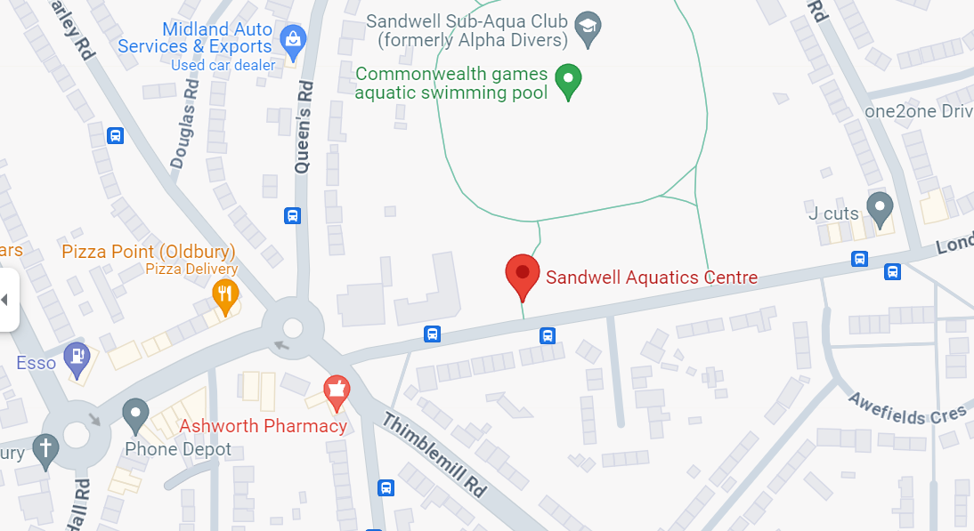





Travelling to the venue

By Bus: Visit Transport for West Midlands to plan your journey.

By Bike: Use the Birmingham CycleStreets Journey Planner for direct and scenic route options.

By Car: Parking at Sandwell Aquatics Centre is free of charge.

On Foot: You can find directions and an estimated walking time using the Google Maps app.

KEY DATES AT A GLANCE
Training Dates: Tuesday 3rd June and Wednesday 4th June 2025
Technical Meeting: Wednesday 4th June @ 17:30
Competition Dates: Thursday 5th June – Sunday 8th June 2025

All coaches, chaperones and physiotherapists must have a valid photo to gain access to the pool deck. Coach pass applications are now open HERE.

Please note that in the dry dive training space there is no working springboard into the pit

TRAINING
Training will be available at the following times during the training days:
Date | Diving Pool | Diving Dryland
Tuesday 3rd June 2025 | 8am – 4pm | 7am – 4pm
Wednesday 4th June 2025 | 8am – 4pm | 7am – 4pm

COMPETITION
Training during the competition days will be available at the following times:
Date | Diving Pool | Diving Dryland
Thursday 5th June 2025 | 8am – 9.45am, in between and post competitions until 8pm | 7am – 8pm
Friday 6th June 2025 | 8am – 9.45am, in between and post competitions until 8pm | 7am – 8pm
Saturday 7th June 2025 | 8am – 10.45am, in between and post competitions until 8pm | 7am – 8pm
Sunday 8th June 2025 | 8am – 10.45am, in between competitions until 1.30pm | 7am – 3pm

TICKETS
Tickets are available to purchase HERE or on arrival from the Ticketing Box Office.

- Doors will be opened to spectators 90 minutes before session start.
- Concessions are those 16 and under, 65 and over and, students (ID required).
- Accessible tickets come with a free complimentary companion ticket.
- Online tickets will be available until 15:00 on Wednesday 4th June 2025. After this time, tickets will only be available for purchase from the Sport Information Desk.
- Ticket prices on the door are as follows:

Ticket Type | Price
Event Pass - Adult | £60.00
Event Pass - Concession | £48.00
Event Pass – Accessible Seating | £48.00
PRELIMS Individual Session Ticket – Adult | £9.50
PRELIMS Individual Session Ticket – Concession | £7.50
PRELIMS Individual Session Ticket – Accessible Seating | £7.50
FINALS Individual Session Ticket – Adult | £12.50
FINALS Individual Session Ticket – Concession | £10.50
FINALS Individual Session Ticket – Accessible Seating | £10.50

MERCHANDISE
Merchandise will be available to purchase on arrival.

SCHEDULE OF EVENTS
*Please note that times are subject to change*
Friday 6th June
Session 3 – 10:00
Men’s 1m Springboard Prelim
Women’s 3m Springboard Prelim

Session 4 – 15:00
Men’s 1m Springboard Final
Women’s 3m Springboard Final

Thursday 5th June
Session 1 – 10:00
Women’s 1m Springboard Prelim
Men’s 3m Springboard Prelim
Session 2 – 15:00
Women’s 1m Springboard Final
Men’s 3m Springboard Final
Men’s and Women’s Platform Synchronised Final

Saturday 7th June
Session 5 – 11:00
Women’s Platform Prelim
Session 6 – 14:00
Men’s 3m Synchronised Final
Women’s Platform Final

Sunday 8th June
Session 7 – 11:00
Men’s Platform Prelim
Session 8 – 14:00
Women’s 3m Synchronised Final
Men’s Platform Final

TECHNICAL MEETING
The technical meeting will take place at 17:30 on Wednesday 4th June in the training room at Sandwell Aquatics Centre.

DIVE SHEETS

Divers/Coaches are requested to submit dive sheets electronically, both for their own convenience and to minimize the chance of errors loading the data into the Recording program. Coaches may make bulk submission of dive sheets on behalf of their divers by using the program DiveSheets with which they will already be familiar. Alternatively, individual divers may submit their own dive sheets on-line. Please agree with your coach which method you should use. To submit your dive sheets on-line there are two options:
- Either visit: www.diverecorder.co.uk/onlinesheets and follow the instructions, or
- if you have an Android phone or tablet, you can get the ADiveSheets app from this page on the DiveRecorder website: www.diverecorder.co.uk/dive/android
As soon as you complete either on-line submission method, you will see a success/failure message.
If you experience problems and need assistance, please contact Jackie Laugher: jackielaugher@yahoo.com

Electronic dive sheets must be submitted where possible. Electronic submissions must be made by 18:00 on Tuesday 3rd June 2025. You will be asked to sign hard copies of these sheets at the venue, available from the Recorders.
If neither you nor your Coach are able to use the above electronic methods, you can submit a hard copy of your lists of dives to the Recorders at Sandwell Aquatics Centre.

If manual dive sheets need to be submitted, submissions must be made by 2 hours before the Technical Meeting.

For late entries, please do not submit a dive sheet until the late entry has been submitted and processed.

EVENT CONDITIONS
Event Conditions for Aquatics GB Diving Championships 2025

General
  - British teams with British eligible divers have an unlimited number of entries, but they must have achieved the respective performance standards in the preceding 12 months (See Table 1.3).
  - Members of International Federations who are also members of British clubs may enter under their British Club, but will follow rules 3.1-3.3
  - Divers must be aged at least 11 years by the 31st December in the year of competition.
  - Late Entries for all events are allowed up to the start of the Technical Meeting, subject to 1.1 above. All late entries will incur a late entry fee. The late entry fee for Synchro will be at the discretion of Aquatics GB Diving Head Coach.
  - Divers may compete exclusively in synchronised events.

Event format
  - Individual events: there shall be 1m, 3m and Platform events. See Table 1.1 for more information.
  - No dive may be repeated in any event.
  - Individual platform dives can be performed from 10m, 7.5m or 5m platforms in prelims and finals. Priority of progression into the platform finals will be given to divers completing their full list from 10m. Any places in the final not filled by those with full 10m platform lists will then be available for divers performing some of their platform list from 5m / 7.5m boards based on points scored in the prelims.
  - Synchronised events: there shall be 3m and 10m events. See Table 1.2 for more information.

Finals
  - In the final divers will perform their dives, competing in the reverse order of their preliminary rankings.
  - The finals will consist of 12 divers, ranked from the preliminary event, at least 6 of which must be British divers.
  - Up to 6 international divers may proceed to the final, but only if they rank in the top 12 in the preliminary event.
  - Following condition (3.3), the remaining places in the final will be comprised of additional British divers in ranked order. This may include British divers originally ranked outside the top 12 in the preliminary event.
  - All Synchronised events will be straight finals.

GUESTS (International Federation entries)
  - Evidence shall be provided, at the time of entry, to confirm that each foreign diver has achieved the performance standard (Table 1.3) for the event they are entering.
  - Multiple club entries from one country will be treated as one International Federation for final qualification purposes.

Awarding of Aquatics GB Championships Medals:
  - Divers eligible to compete for Great Britain are eligible for British Medals. In all events there will be Open and Closed medals.
  - Open medals will be awarded if a diver not eligible to compete for Great Britain, placed in the top 3 in a Final.
  - In Platform competitions, only divers performing ALL dives from the 10m board are eligible for medals.

Selection to British Teams
  - Divers wishing to be eligible for selection in platform competitions for either Team A or Team B must compete all dives from the 10m platform. All selections will be based upon the published Selection Policy.

INDIVIDUAL (Table 1.1)

Category | Gender | Dives | Conditions
1m | Male | 6 dives | 6 dives from 5 groups no limit.
3m | Male | 6 dives | 6 dives from 5 groups, no limit.
5m, 7.5m and/or 10m | Male | 6 dives | 6 dives from 6 groups no limit.
1m | Female | 5 dives | 5 dives from 5 groups no limit.
3m | Female | 5 dives | 5 dives from 5 groups no limit.
5m, 7.5m and/or 10m | Female | 5 dives | 5 dives from 5 groups no limit.

Synchronised Pairs (Table 1.2)
Category | Gender | Dives | Conditions
3m | Male | 6 dives | 2 dives with an allocated dd of 2.0 plus 4 x optional dives. 5 groups to be covered
10m | Male | 6 dives | 2 dives with an allocated dd of 2.0 plus 4 x optional dives. 5 groups to be covered
3m | Female | 5 dives | 2 dives with an allocated dd of 2.0 plus 3 x optional dives. 5 groups to be covered
10m | Female | 5 dives | 2 dives with an allocated dd of 2.0 plus 3 x optional dives. 5 groups to be covered

PERFORMANCE STANDARDS FOR NATIONAL CHAMPIONSHIPS (Table 1.3)

Gender | Event | Conditions | No. of Dives | Standard
Women | 1m | 5 from 5 | 5 | 190
Women | 3m | 5 from 5 | 5 | 210
Women | Platform | 5 from 5 | 5 | 210
Men | 1m | 6 from 5 | 6 | 250
Men | 3m | 6 from 5 | 6 | 300
Men | Platform | 6 from 6 | 6 | 300

DOPING CONTROL

By entering this event the athlete consents to report to Doping Control, if requested, at any time during this event and agrees to abide by the British Swimming Anti-Doping Rules (2021).

If an athlete is subject to doping control, they should ensure they provide detail of all medications (prescribed or over the counter and including dosage) and supplements taken within the last 7 days in advance of the test and (where the sample collected is a blood sample) blood transfusions within the previous three (3) months, on the Doping Control Form. Any previously disclosed medications or supplements to your club and/or your home nation do not form any part of doping control.

Please check your medications via https://www.globaldro.com/uk/search

If the medication you are taking is prohibited in or out of competition you may require a TUE. Please read the details below.

Therapeutic Use Exemption (TUE)

If an athlete IS WITHIN the National TUE Pool they are required to obtain a TUE before using a prohibited medication or method. You can check if you are within the National TUE Pool via https://www.ukad.org.uk/national-tue-pool and selecting ‘aquatics’.

If an athlete is NOT within the National TUE Pool but using a prohibited medication or method and is subject to doping control they are required to apply for a retroactive TUE and you should contact Jane Smith (jane.smith@aquaticsgb.com or 07917 834785) as soon as possible after doping control. A retroactive TUE must be submitted to UKAD within five (5) working days of the testing taking place.

You can find out more information about Medications on the UKAD website https://www.ukad.org.uk/medicine

If you require support or have a query about any medications, supplements or the anti-doping rules please contact Jane Smith at Aquatics GB via jane.smith@aquaticsgb.com or 07917 834785

Strict Liability means and athlete is wholly responsible for any banned substance found in their system, no matter how it got there.

ACCREDITATION
All competitors, coaches, chaperones and support staff must have a valid accreditation to gain access to athlete areas at the event. Accreditation is non-transferable and must be always worn when accessing athlete areas.
If the pass is forgotten, lost or mislaid, a replacement pass will be re-issued for a fee of £10.00 at the Sport Information Desk.

ATHLETES
Your accreditation will be sent to you by email in PDF format upon completion of your entry.
Please print and bring with you to the event where you can collect a pouch and lanyard from the Sport Information Desk.
If you are unable to find the accreditation link within the confirmation email, you can issue yourself a replacement via the link HERE

Coaches, team staff, chaperones
All coaches, team staff and, chaperones and must have a valid photo to gain access to the pool deck. Applications for coach/chaperone passes will be charged at £10.
A valid DBS check, safeguarding qualification and fulfilment of the minimum qualification/requirement for the specific role (stated below) you are undertaking is required.

 | Application Links
Swim England members | HERE
Scottish Swimming/Swim Wales members | HERE
Sports Science/Sports Medicine | HERE
International | HERE

DBS/PVG AND SAFEGUARDING

Swim England
All Swim England clubs and license applicants will have completed a DBS application regardless of any previous check carried out through another organisation unless this has been registered with the DBS Update Service www.gov.uk/dbs-update-service. If you hold a disclosure that has been registered with the DBS Update Service, and you have not yet given the Swim England written consent to check the status, please submit your original disclosure certificate along with a completed consent form to dbs@swimming.org. Please also email dbs@swimming.org for a DBS Update Service Consent form.

Scottish Swimming/Swim Wales
For queries regarding PVG for Scottish Swimming members, please email wellbeingprotection@scottishswimming.com. For queries regarding DBS for Swim Wales members, please email welfare@swimwales.org.
PLEASE NOTE: Scottish Swimming, Swim Wales and International Poolside Passes must be created and sent manually. They will be sent out prior to the event if you have the appropriate Safeguarding checks and qualifications on file.
.

Minimum Qualification/Requirements (specific to accredited role)
- Coaches - Coaching Qualification or Assistant Coach Certificate
- Team Manager – Team Manager Training Module 1 or 2 Certificate
- Chaperone – Club authorisation to be acting in loco parentis on behalf of the Club

PLEASE NOTE: It is the applicant’s responsibility to ensure a DBS is in place and a pass has been purchased to attend the event. Under no circumstances will any person be allowed entry to accredited areas without the relevant safeguarding checks in place and pass issued.
Please email british.events@aquaticsgb.com if you have any queries.

Accreditations will be emailed to you in PDF format to print out and bring to the event, please ensure you print these before arriving at the venue. Pouches and lanyards will be provided.
Athletes/Coaches/Team Staff/Chaperones will not be allowed on poolside without a valid accreditation.

MEDICAL
Paramedics and an ambulance (Arley Medical Services) will be on site during the competition dates, Thursday 5th June – Sunday 8th June. Pool staff will administer first aid where necessary.
Closest hospital to Sandwell Aquatics Centre with and A&E department is:
Midland Metropolitan University Hospital, Grove Ln, Smethwick B66 2QT
Tel: 0121 553 1831

SEXUAL HARASSMENT


FILMING AND PHOTOGRAPHY

Filming and Photography policy
Aquatics GB are aware of the wide range of devices including mobile telephones which have photographic and filming capabilities. This enables the capture of both static and moving images. It should be acknowledged that the majority of images taken within an Aquatics GB setting are appropriate and taken in good faith. However, images of children and adults can be misused, and sharing images widely without consent may betray a confidence or identify of a child or adult, which could present a risk of harm to that individual if common sense procedures are not followed.
Parents and carers of participants under the age of 18 who wish to take images are requested to focus on their own children as much as reasonably possible and to avoid including other children in images, particularly if those images are being shared with family and friends or through social media platforms. Whilst it is acknowledged that parents/carers wish to celebrate the achievements of their own children when taking part in aquatic events, it should be recognised and respected that other parents/carers may not wish for their child’s image to be taken and shared in this way.
Aquatics GB encourage all spectators and participants at Aquatics GB events to make themselves familiar with the photography and filming arrangements for the event and be vigilant during that event.
Aquatics GB is committed to ensuring that all children who participate in Aquatics GB activities can take part in an enjoyable, safe environment and be safeguarded from harm. If you have any child safeguarding concerns at the event, please contact an Event Officer immediately to disclose your concerns.

EVENT PHOTOGRAPHY AND FILMING
This event will be photographed and live streamed. Static images will be displayed on the Aquatics GB website here. They will be used to promote the sport at this event and events in the future. Moving images may be displayed at the venue and via live stream here. In addition, Aquatics GB may use these recordings and images for the purposes of education and training, swimmer analysis, promotion, performance, development and selection and event analysis.
In such instances where the event is being live streamed, it will not be possible to provide the option to refuse consent to filming and if there are any concerns, please speak to the Event Officer present. However, if individuals wish to refuse consent to static photography, please complete the Photography Refusal of Consent Form below and return to Aquatics GB Events Department.
If you, as a Parent/Guardian/Carer, have concerns about your child being photographed/filmed, please refer to the relevant Home Nation guidance document: Wavepower the Swim England Child Safeguarding Policy and Procedures; YPlant the Swim Wales Child Protection Policy; Scottish Swimming Child Protection Policy. If you have any concerns in this area, please contact the Data Protection Officer.
Our photography refusal form is available on the next page.
Please note that professional photography is not permitted at this event without prior written consent. Personal photography for private use is welcome provided it does not disrupt the event or infringe on the privacy of others. Aquatics GB reserves the right to request that certain photography devices are not used.

PHOTOGRAPHY REFUSAL FORM

Name of Diver: ________________________________________________

Membership Number: ________________________________________________

Event: Aquatics GB Diving Championships 2025

I refuse permission for the taking and/or publication of images of my child or myself by the event’s Official Photographer(s):

Signed _______________________________________________ (Competitor/Parent/Carer)

Print Name: ________________________________________________

Date:_______________________________________________

Please return this form by email to: holly.martindale@aquaticsgb.com

ENTRIES
ENTRIES AT 21ST MAY 2025
Thursday 5th June 2025
Session 1 – 10:00
PRELIM Women’s 1m
1 | Megan Beasley |  | Co Bradford Esprit
2 | Desharne Bent-Ashmeil |  | Dive London
3 | Matilda Brown |  | Co Sheffield DC
4 | Lois Bruce |  | Co Sheffield DC
5 | Scarlett Colbourne |  | Plymouth DC
6 | Yasmin Harper |  | Co Sheffield DC
7 | Clara Kerr |  | Edinburgh DC
8 | Katie Martin |  | Plymouth DC
9 | Maia Pearson |  | Plymouth DC
10 | Grace Reid |  | Dive London
11 | Evie Smith |  | Co Sheffield DC
12 | Amelie Underwood |  | Plymouth DC

PRELIM Men’s 3m
1 | Leon Baker | Co Sheffield DC
2 | Archie Biggin | Co Sheffield DC
3 | Matthew Dixon | Dive London
4 | Todd Geggus | Southend D
5 | Simeon Greig | Co Sheffield DC
6 | Anthony Harding | Co Sheffield DC
7 | Ross Haslam | Co Sheffield DC
8 | Ollie Heath | Plymouth Diving
9 | Jordan Houlden | Co Sheffield DC
10 | Oscar Kane | Dive London
11 | Jack Laugher | Co Sheffield DC
12 | Shane McConnell | Edinburgh DC
13 | Noah Penman | Aberdeen DC
14 | Lachlan Stark | Edinburgh DC
15 | Hugo Thomas | Dive London
16 | Oscar Willcox | Co Sheffield DC

Session 2 – 15:00
FINAL Women’s 1m
FINAL Men’s 3m

FINAL Men’s Platform Synchro

FINAL Women’s Platform Synchro
1 | Maisie Bond  Lois Toulson | Co Sheffield DC
 | Maisie Bond  Lois Toulson | Co Sheffield DC

Friday 6th June 2025
Session 3 – 10:00
PRELIM Men’s 1m
1 | Leon Baker |  | Co Sheffield DC
2 | Matthew Dixon |  | Dive London
3 | Simeon Greig |  | Co Sheffield DC
4 | Ross Haslam |  | Co Sheffield DC
5 | Ollie Heath |  | Plymouth Diving
6 | Jordan Houlden |  | Co Sheffield DC
7 | Charlie Minns |  | Albatross DC
8 | Logan Soutar |  | Sandwell DC
9 | Lachlan Stark |  | Edinburgh DC
10 | Hugo Thomas |  | Dive London
11 | Oscar Willcox |  | Co Sheffield DC

PRELIM Women’s 3m
1 | Megan Beasley | Co Bradford Esprit
2 | Desharne Bent-Ashmeil | Dive London
3 | Matilda Brown | Co Sheffield DC
4 | Lois Bruce | Co Sheffield DC
5 | Yasmin Harper | Co Sheffield DC
6 | Clara Kerr | Edinburgh DC
7 | Grace Reid | Dive London
8 | Amy Rollinson | Dive London
9 | Evie Smith | Co Sheffield DC
10 | Amelie Underwood | Plymouth DC

Session 4 – 15:00
FINAL Men’s 1m
FINAL Women’s 3m

Saturday 7th June 2025
Session 5 – 11:00
PRELIM Women’s Platform
1 | Maisie Bond |  | Co Sheffield DC
2 | Corin Burrows Mackley |  | Dive London
3 | Libby Duke |  | Edinburgh DC
4 | Tia McGarry |  | Co Sheffield DC
5 | Libby Mitson |  | Co Leeds DC
6 | Hannah Newbrook |  | Dive London
7 | Andrea Spendolini-Sirieix |  | Dive London

Session 6 – 14:00

FINAL Men’s 3m Synchro
1 | Leon Baker  Hugo Thomas | Co Sheffield DC
 | Leon Baker  Hugo Thomas | Dive London
2 | Todd Geggus  Connor Lano | Southend DC
 | Todd Geggus  Connor Lano | Southend DC
3 | Anthony Harding  Jack Laugher | Co Sheffield DC
 | Anthony Harding  Jack Laugher | Co Sheffield DC
4 | Shane McConnell  Lachlan Stark | Edinburgh DC
 | Shane McConnell  Lachlan Stark | Edinburgh DC
FINAL Women’s Platform

Sunday 8th June 2025
Session 7 – 11:00
PRELIM Men’s Platform
1 | Archie Biggin |  | Co Sheffield DC
2 | Ben Cutmore |  | Dive London
3 | Jorden Fisher-Eames |  | Dive London
4 | Robbie Lee |  | Dive London
5 | Euan McCabe |  | Plymouth DC
6 | Shane McConnell |  | Edinburgh DC
7 | Noah Penman |  | Aberdeen DC
8 | Robert Wood |  | Co Sheffield DC

Session 8 – 14:00

FINAL Women’s 3m Synchro
1 | Matilda Brown  Evie Smith | Co Sheffield DC
 | Matilda Brown  Evie Smith | Dive London
2 | Desharne Bent-Ashmeil  Amy Rollinson | Dive London
 | Desharne Bent-Ashmeil  Amy Rollinson | Dive London
3 | Yasmin Harper  Scarlett Mew-Jensen | Co Sheffield DC
 | Yasmin Harper  Scarlett Mew-Jensen | Dive London
FINAL Men’s Platform

