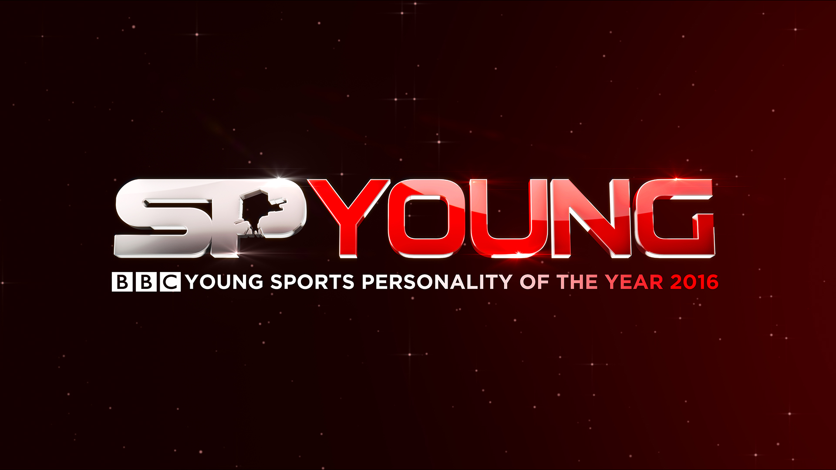
BBC Young Sports Personality of the Year 2016
Nomination Form

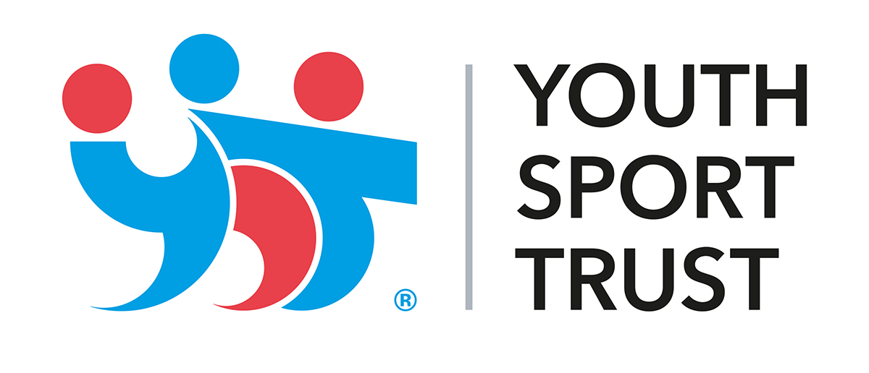
BBC Young Sports Personality of the Year will be awarded to the outstanding young British sportsperson aged 17 or under on 1 January 2016, selected from nominations made to the BBC and by sports governing bodies via the Youth Sport Trust.

The Youth Sport Trust is an independent charity devoted to changing young people’s lives through sport. We are passionate about helping all young people to achieve their full potential in life by delivering high quality physical education and sport opportunities.

If not citizen of the UK, the nominee needs to meet all three of the following criteria:
• They play a significant amount of their sport in the UK
• Their core achievements that year were achieved in the UK and not with a national team
• They are residents in the UK

Nominated athletes must have been 17 years of age or younger on January 1, 2016
Nominated athletes must not be related to the person nominating them

We will only use the information on this form for the purposes of administering this award and will not retain the data.

Nominee Name
Date of Birth
Age on 1 January
Address
Telephone no(s)
Email address
Sport
Club
School/College
School/College postcode

Representative sporting honours at international level and main achievements:

Evidence of strong record of attendance/commitment to school/education relevant to sport:

Evidence of being a good and supportive role model in the world of sport:

Nominator name
Nominator address
Nominator tel.
Nominator email
A panel of judges will meet in mid-November to decide the Top 10 contenders from the list of nominations collected by the BBC and the Youth Sport Trust. The same panel will also select the Top 3 contenders and the winner by secret ballot. The final vote will be independently verified.
The Top 3 will be invited to the live event and the other seven contenders will be notified out of courtesy that they have not made the final shortlist.

The winner will be announced live on the Sports Personality of the Year show on Sunday 18th December 2016.

Please return completed form via email or post by Friday 11th November, 2016

Either attach your completed form and email to sports.personality@bbc.co.uk
or post to YOUNG SPOTY 2016, 3rd Floor, Quay House, MediaCityUK, Salford Quays M50 2QH

The winner will become a Sporting Patron of the Youth Sport Trust for 2016

BBC Sports Personality of the Year - Sunday 18th December 2016


